

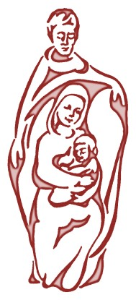

Holy Family’s Child Friendly Anti-Bullying Policy

2026-2027

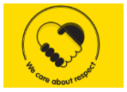


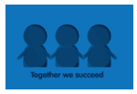
Holy Family is truly a special place where we are more than a school - we are a family. As a Catholic school we place Christ at the centre of all that we do; encouraging children to be the best they can be as they walk in the footsteps of Jesus. This is demonstrated daily with our Mission Statement and Values ensuring that Holy Family is a vibrant and happy place to learn and grow.

What is bullying?
There are different types of bullying. If other people are making you feel sad over and over again, either through their words or actions this could be classed as bullying.

Types of Bullying

Physical Bullying | Punching, kicking, hitting, scratching, spitting, biting, pushing, hair pulling, pinching, slapping, taking belongings.
Verbal Bullying | Being teased, name calling, mocking, offensive comments, insults, threats, telling lies about you.
Emotional Bullying | Hurting feelings, being left out, pulling faces.
Cyber Bullying | Unkind words by using texting and phone calls, online social media and email, hurtful videos, sending people things without permission, hacking into other people’s accounts, posting things without people’s permission.
Written Bullying | Hurtful letters/notes, graffiti.

What should you do if you think you are being bullied?

Do | Don’t
Ask them to stop | Do what they say
Walk away | Get angry
BE BRAVE | Be unkind back
Get help | Hide
Go to Pastoral drop in | Think it’s your fault
Talk to a friend you TRUST | Stay quiet  Talk to an adult you TRUST
Talk to an adult you TRUST for example parents, guardians, TA’s and teachers | Shout back at them
Stand up for yourself
Ignore hurtful comments and be a helping hand | Don’t get people to turn against them.

What should I do if I think someone else is being bullied?

Do | Don’t
Be a good friend | Walk away
Encourage them to tell someone they TRUST | Be scared
Encourage them to talk about what has happened | Ignore what you have seen or heard
Tell an adult yourself | Stay quiet
Be the bridge of friendship | Be a bystander
Console the person being bullied.

Who can you talk to?
- A friend
- A buddy from another class
- A family member
- An adult in school
- Worry box
- Any adult you TRUST
What happens next?
- The incident will be dealt with by a member of staff and recorded
The person being bullied will be made to feel SAFE and given pastoral support
- Staff will talk to everyone involved.
- The headteacher will be told straight away
- Staff will tell other adults so they can keep you safe and happy
- Staff will talk to parents
- Consequences will be given to children involved
- Adults will continue to support

Everyone at Holy Family Catholic Primary school will work together to:

Make our school a place where everyone can feel safe, happy and welcome.
Stop and prevent bullying.
Treat others how we would like to be treated.
Allow others to realise they have the right to be who they are.

