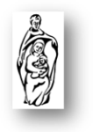
Holy Family catholic primary school
wellbeing Newsletter
Summer 1

Dear Parents and Carers,

Well, can you believe that we are at the end of another half term? This one seems to have flown by as we have had so much going on around school! I know that the children will be ready for a break. This half term has been tricky for many our children, particularly those taking statutory assessments. We really are so proud of their perseverance! Year 6 had the opportunity to work on their wellbeing and celebrate the end of their exams during their action-packed trip to Kingswood. It was wonderful to see their smiling faces and listen to how much fun they had.

Since continuing Miss Hoyle’s hard work, I have hit the ground running with looking into what we can do to support the mental health of our children. At the beginning of the half term, we recruited our ‘Mental Health Champions’ who have been our pupil voice for wellbeing. They have come up with some fantastic ideas for what they’d like to see happening in school. Firstly, they wanted to spread kindness and reward those who do kind things. They introduced ‘kindness tickets’ and the classes have been collecting them weekly. At the end of the week, the class with the most kindness tickets has been awarded with a ‘kindest class’ award to display in their classroom. Well done to all the classes who have been awarded one of these so far! It is wonderful to see the children going the extra mile to be kind to one another and staff. The Mental Health Champions have been looking into other things that they’d like to do, so watch this space!

Over the half term break, it would be wonderful if our families could go the extra mile to spend time together. This can be so difficult with the commitments of daily life, but even just going for a short walk, having a movie night or playing games with those we love can do wonders for our mental wellbeing.

Have a wonderful rest,

Mrs Hancock

Half term wellbeing challenge!
I’d like to set the children a wellbeing challenge to complete over the holidays. It would be amazing if everybody could have a go at helping in the kitchen in some way. Perhaps they could bake a cake, cookies, make a fruit salad or simply help to prepare dinner one night. Cooking is a great way for the children to practise a completely different skill that they may not have had the opportunity to do before. Send photos of your completed challenge to your class teachers on seesaw! We cannot wait to see what you produce!

Mindfulness to relieve stress and anxiety
Staff are always looking for ways to reduce stress and anxiety in our children at Holy Family. Quite often, we use mindfulness as a tool to do this. Mindfulness is the practice of being ‘in the moment’ and focusing your thoughts. Why not try this at home with your child? You might even find that, after a busy day, it really helps you too!
Below you will find some links to great mindfulness sessions to do with your child at home:
https://www.youtube.com/watch?v=Bk_qU7l-fcU
https://www.youtube.com/watch?v=mV9BBR1RoGg
https://www.youtube.com/watch?v=DWOHcGF1Tmc

Supporting your child with transition
Next half term, transition will be high on our agenda at Holy Family. We will be doing lots of things to make moving up to a new year group a smooth process for our children. There are lots of ways that you can support with this at home and reduce any anxiety that your children might be feeling. Being open to talking about change and answering your child’s questions is a great start, as well as being positive about having the opportunity to begin a new adventure!
Here are some great books around transition, which will hopefully get the conversation going for anybody who feels their child may benefit…
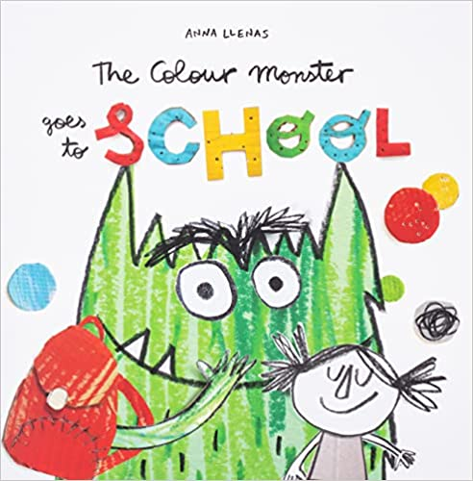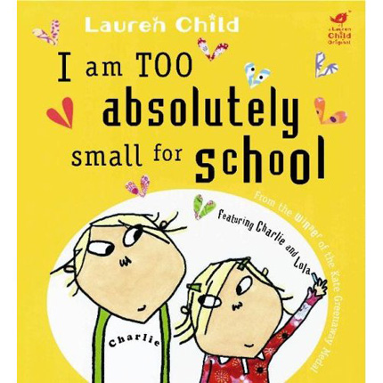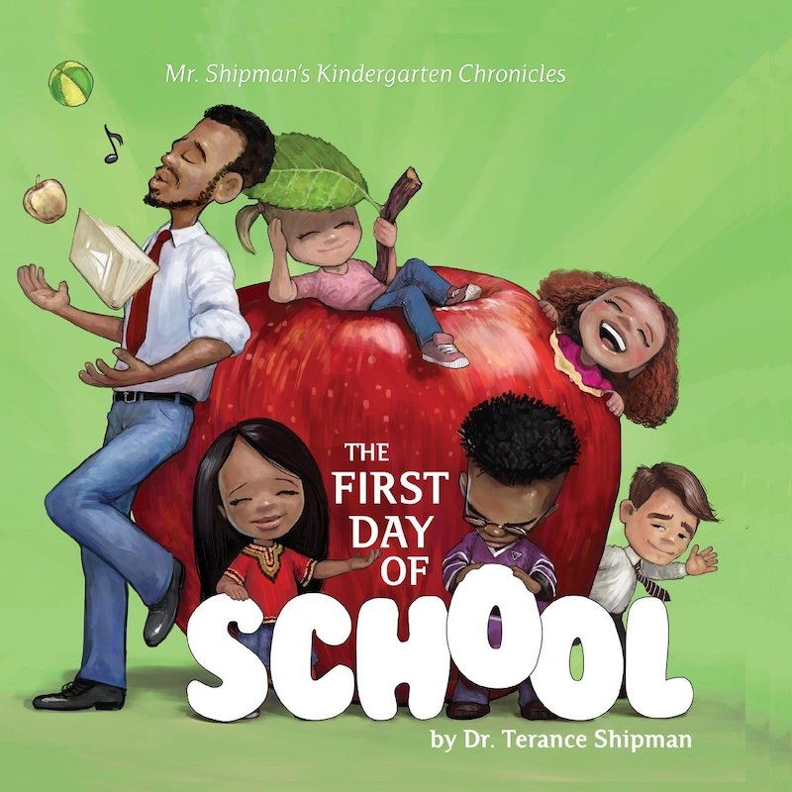

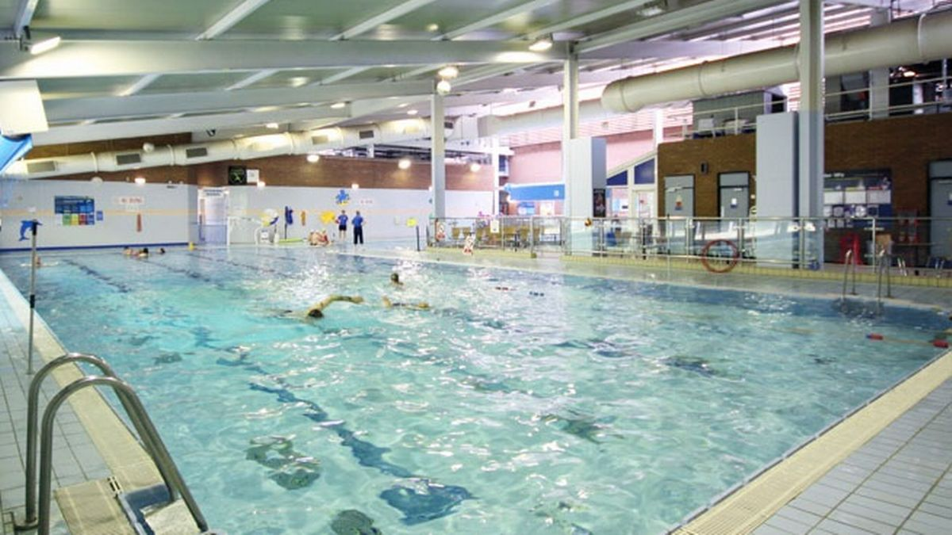
Why not visit your local leisure centre to get active. Swimming is great exercise and can be lots of fun for the whole family. You can book online with the link below to use Trafford leisure centres facilities
https://traffordleisure.co.uk/swimming-timetable/

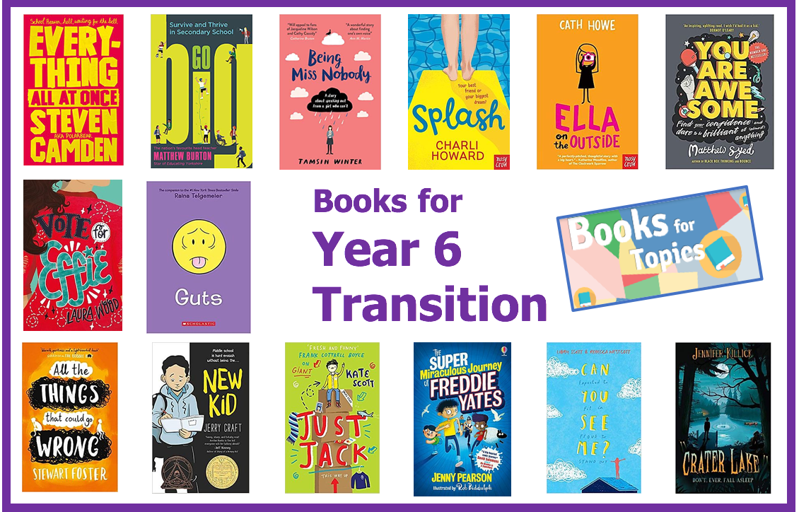

Useful links
https://www.nhs.uk/nhs-services/mental-health-services/mental-health-services-for-young-people/children-young-people-mental-health-services-cypmhs-parents-carers-information/
https://www.youngminds.org.uk/
https://www.nspcc.org.uk/keeping-children-safe/childrens-mental-health/
https://www.bbc.co.uk/newsround/54058778
https://www.nhs.uk/conditions/baby/health/sleep-problems-in-young-children/



