
Holy Family Catholic Primary School
Old Hall Road, Sale Moor, Cheshire M33 2JA
Tel: 0161 962 5397
School Email: admin@holyfamilysalemoor.co.uk
Website: www.holyfamilysalemoor.co.uk
Twitter: @HolyFamilySale
Headteacher: Mrs L Davison BA Hons NPQH
Dear Parents,

As part of the government’s efforts to improve literacy levels through high – quality phonics teaching, they have more recently published a list of validated systematic synthetic phonics programmes which they have recommended that schools follow. The aim of these schemes are to give all children a solid base upon which to build as they progress through school, and to develop in children a habit of reading widely and openly, for both pleasure and information.

Having reflected upon this advice, by conducting research and considering our current position with regard to the teaching of phonics and early reading at Holy Family, we have decided to implement an exciting new approach to this area of our curriculum through engagement with ‘Little Wandle Letters and Sounds Revised’.

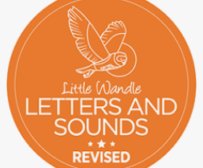

Little Wandle Letters and Sounds Revised covers phonics teaching from the beginning of Reception through to the end of Year 1; beginning at Phase 2, finishing at Phase 5 and extending provision for those children who may need it during their journey of learning. In addition, within the Nursery phase, it provides the children with a range of foundations such as oral blending to support their progress as they move forward with their learning.

Phonemic awareness (distinguishing the sounds which make up words) is a crucial skill underpinning phonics and reading; something which is strengthened through the early learning of phonics. Therefore, all of our children in Reception and Key Stage 1 will begin to take part in the revised daily Little Wandle phonics lessons from Monday 13th September 2021. These sessions will be taught within the children’s classrooms, ensuring that there is both pace and progression for all of our children.

Alongside these daily phonics sessions, once children are ready to, they will take part in three reading practise sessions per week. During these sessions, they will have the opportunity to apply their phonics’ learning when reading a range of decodable books, matched to their current individual progress. These sessions will give the children the opportunity to revisit any graphemes and tricky words, explore unfamiliar vocabulary and read with fluency; developing their decoding, prosody and comprehension skills.

A strong reading relationship between home and school will remain a key part of this new approach. It is our role as a school to teach your child to read. As parents, providing your child with a wealth of reading opportunities at home will support them in becoming fluent, confident readers. Therefore children across KS1 will bring home two books, a reading practice book which will be matched to your child’s phonics stage and which they will be able to read independently and a sharing book which they can talk about and enjoy with you.

The reading practice book.
Your child will bring this book home once a week as a celebration of their learning across that week. This book will be matched to their phonic stage and be fully decodable. In order for your child to build fluency, it is vital that they are able to read 95% of the words in the text, therefore requiring little help. As a parent, it is key for you to listen with interest, encourage and praise your child enthusiastically when they read this book, returning to the text and talking about it afterwards.
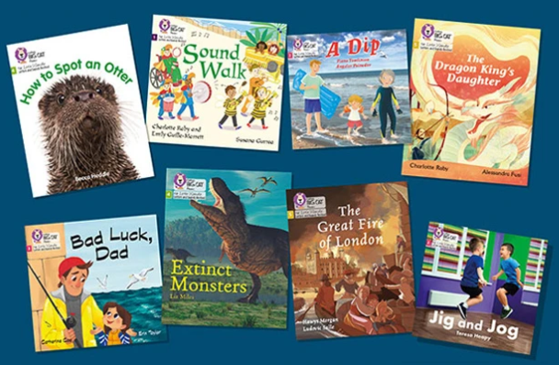

The sharing book.
If your child is to become a lifelong reader then it is essential that they are encouraged to read for pleasure. To help in fostering this love of reading, your child will also bring home a sharing book to share and enjoy. These books will provide your child with opportunities to talk about pictures, characters and plots; for your child to dream with their eyes open. We do not expect your child to read these books independently; they should be read to them. The aim of this book is enjoyment.

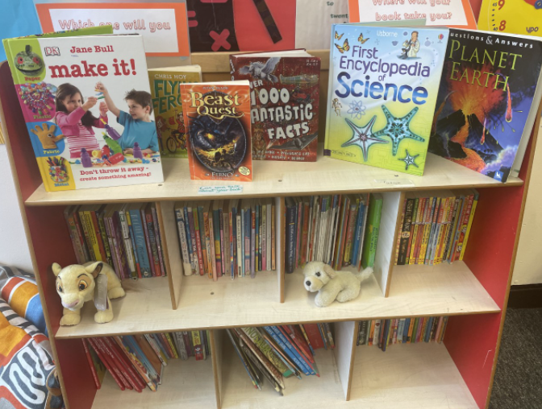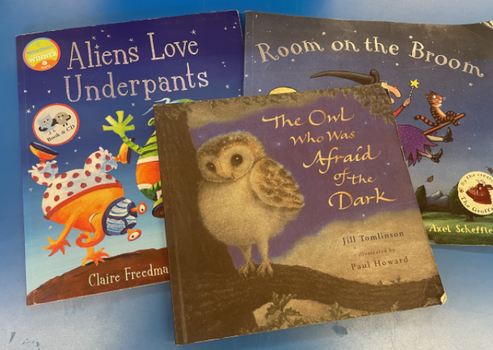

Parental engagement.
As parents, you can support your child further with their phonics learning, by accessing a range of further resources such as videos and letter formation guidance on the Little Wandle website. Please click on the link below to find out more.
https://www.littlewandlelettersandsounds.org.uk/resources/for-parents/

This is a really exciting time for us to ignite our children’s passion for reading, whilst supporting them in growing their phonics’ knowledge along the way. #togetherwesucceed


With regards,
Mrs N Holland
Acting Deputy Headteacher

